Advanced Programming

Assignment 1

Word Ladder Problem

Name: Mian Ihtisham Shah

Registration No. : 33083

Class: BSCS-4B

Analysis

Read the json file into list called Dictionary. Re ordered that list alphabetically and according to the word length.

Found the total number of words of the same length and added to dictionary. This dictionary is used to iterate only the values of the Dictionary which have same length as the Starting word.

Breadth First Search was used to found the shortest chain between 2 words. This function would return a list of words i.e. chain. The same function was used to find chains between every word in the dictionary. After the chains between a word and every other word was generated its appending to a csv file.

In order to obtain the frequency distribution table and it’s associated chart, each csv file is scanned and frequency of chain length recorded in a dictionary, and then appended to csv file called chainLength. This same data is used to find the longest chain(s) length.

*Because of time constraint the only chains till DEL with every other word in the dictionary was found.*

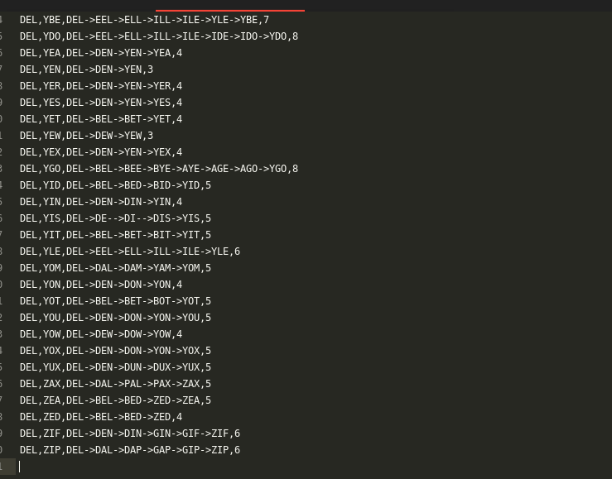

Max Chain Length:

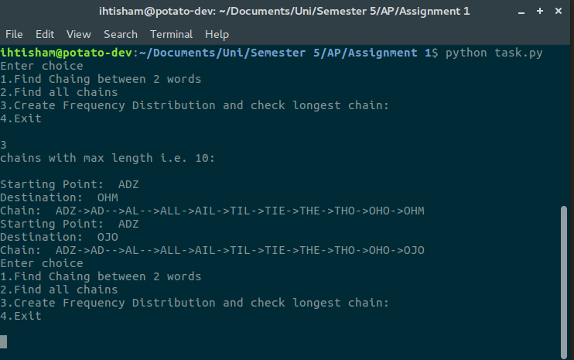

Frequency Distribution Table:

